# NYU Tandon School of Engineering Fall 2022, ECE 6913

**Homework Assignment 7** *Instructor: Azeez Bhavnagarwala,* email: [ajb20@nyu.edu](mailto:ajb20@nyu.edu) *Course Assistants*

Varadraj Kakodkar (vns2008), Kartikay Kaushik (kk4332), Siddhanth Iyer (si2152), Swarnashri Chandrashekar (sc8781), Karan Sheth (kk4332), Haotian Zheng (hz2687), Haoren Zhang (kk4332), Varun Kumar (vs2411)

**Homework Assignment 6** [released Friday November 11th 2022] [due Monday November 28th by 11:59PM]

You *are allowed* to discuss HW assignments with anyone. You are *not allowed* to share your solutions with other colleagues in the class. Please feel free to reach out to the Course Assistants or the Instructor during office hours or by appointment if you need any help with the HW.

Please enter your responses in this Word document after you download it from NYU Classes.

*Please use the Brightspace portal to upload your completed HW.*

*.*

1. Caches are important to providing a high-performance memory hierarchy to processors. Below is a list of 64-bit memory address references, given as word addresses.

0x02, 0xb3, 0x2a, 0x01, 0xbe, 0x57, 0xbf, 0x0d, 0xb6, 0x2b, 0xbc, 0xfd

* 1. For each of these references, identify the binary word address, the tag, and the index given a direct-mapped cache with 16 one-word blocks. Also list whether each reference is a hit or a miss, assuming the cache is initially empty.

|  |  |  |  |  |
| --- | --- | --- | --- | --- |
| Address references | Binary Reference | Tag | Index | Hit or Miss |
| 0x02 | 0000 0010 | 0 | 2 | Miss |
| 0xb3 | 1011 0011 | b | 3 | Miss |
| 0x2a | 0010 1010 | 2 | a | Miss |
| 0x01 | 0000 0001 | 0 | 1 | Miss |
| 0xbe | 1011 1110 | b | e | Miss |
| 0x57 | 0101 0111 | 5 | 7 | Miss |
| 0xbf | 1011 1111 | b | f | Miss |
| 0x0d | 0000 1101 | 0 | d | Miss |
| 0xb6 | 1011 0110 | b | 6 | Miss |
| 0x2b | 0010 1011 | 2 | b | Miss |
| 0xbc | 1011 1100 | b | c | Miss |
| 0xfd | 1111 1101 | f | d | Miss |

* 1. For each of these references, identify the binary word address, the tag, the index, and the offset given a direct-mapped cache with two-word blocks and a total size of eight blocks. Also list if each reference is a hit or a miss, assuming the cache is initially empty.

|  |  |  |  |  |  |
| --- | --- | --- | --- | --- | --- |
| Address references | Binary Reference | Tag | Index | Offset | Hit or Miss |
| 0x02 | 0000 0010 | 0 | 1 | 0 | Miss |
| 0xb3 | 1011 0011 | b | 1 | 1 | Miss |
| 0x2a | 0010 1010 | 2 | 5 | 0 | Miss |
| 0x01 | 0000 0001 | 0 | 0 | 1 | Miss |
| 0xbe | 1011 1110 | b | 7 | 0 | Miss |
| 0x57 | 0101 0111 | 5 | 3 | 1 | Miss |
| 0xbf | 1011 1111 | b | 7 | 1 | Hit |
| 0x0d | 0000 1101 | 0 | 6 | 1 | Miss |
| 0xb6 | 1011 0110 | b | 3 | 0 | Miss |
| 0x2b | 0010 1011 | 2 | 5 | 1 | Hit |
| 0xbc | 1011 1100 | b | 6 | 0 | Miss |
| 0xfd | 1111 1101 | f | 6 | 1 | Miss |

* 1. You are asked to optimize a cache design for the given references. There are three direct-mapped cache designs possible, all with a total of eight words of data:

C1 has 1-word blocks,

C2 has 2-word blocks, and C3 has 4-word blocks.

For C1, total number of blocks are 8. Thus, the index bits are 3 bits.

|  |  |  |  |  |
| --- | --- | --- | --- | --- |
| Address references | Binary Reference | Tag (first 5 bits) | C1 | |
| Index | Hit or Miss |
| 0x02 | 0000 0010 | 0x00 | 2 | Miss |
| 0xb3 | 1011 0011 | 0x16 | 3 | Miss |
| 0x2a | 0010 1010 | 0x05 | 2 | Miss |
| 0x01 | 0000 0001 | 0x00 | 1 | Miss |
| 0xbe | 1011 1110 | 0x17 | 6 | Miss |
| 0x57 | 0101 0111 | 0x0a | 7 | Miss |
| 0xbf | 1011 1111 | 0x17 | 7 | Miss |
| 0x0d | 0000 1101 | 0x01 | 5 | Miss |
| 0xb6 | 1011 0110 | 0x16 | 6 | Miss |
| 0x2b | 0010 1011 | 0x05 | 3 | Miss |
| 0xbc | 1011 1100 | 0x17 | 4 | Miss |
| 0xfd | 1111 1101 | 0x1f | 5 | Miss |

For C2, total number of blocks are 4. Thus, the index bits are 2 bits.

|  |  |  |  |  |
| --- | --- | --- | --- | --- |
| Address references | Binary Reference | Tag (first 5 bits) | C2 | |
| Index | Hit or Miss |
| 0x02 | 0000 0010 | 0x00 | 1 | Miss |
| 0xb3 | 1011 0011 | 0x16 | 1 | Miss |
| 0x2a | 0010 1010 | 0x05 | 1 | Miss |
| 0x01 | 0000 0001 | 0x00 | 0 | Miss |
| 0xbe | 1011 1110 | 0x17 | 3 | Miss |
| 0x57 | 0101 0111 | 0x0a | 3 | Miss |
| 0xbf | 1011 1111 | 0x17 | 3 | Miss |
| 0x0d | 0000 1101 | 0x01 | 2 | Miss |
| 0xb6 | 1011 0110 | 0x16 | 3 | Miss |
| 0x2b | 0010 1011 | 0x05 | 1 | Hit |
| 0xbc | 1011 1100 | 0x17 | 2 | Miss |
| 0xfd | 1111 1101 | 0x1f | 2 | Miss |

|  |  |  |  |  |
| --- | --- | --- | --- | --- |
| Address references | Binary Reference | Tag (first 5 bits) | C3 | |
| Index | Hit or Miss |
| 0x02 | 0000 0010 | 0x00 | 1 | Miss |
| 0xb3 | 1011 0011 | 0x16 | 1 | Miss |
| 0x2a | 0010 1010 | 0x05 | 1 | Miss |
| 0x01 | 0000 0001 | 0x00 | 0 | Miss |
| 0xbe | 1011 1110 | 0x17 | 1 | Miss |
| 0x57 | 0101 0111 | 0x0a | 1 | Miss |
| 0xbf | 1011 1111 | 0x17 | 1 | Miss |
| 0x0d | 0000 1101 | 0x01 | 0 | Miss |
| 0xb6 | 1011 0110 | 0x16 | 1 | Miss |
| 0x2b | 0010 1011 | 0x05 | 1 | Miss |
| 0xbc | 1011 1100 | 0x17 | 0 | Miss |
| 0xfd | 1111 1101 | 0x1f | 0 | Miss |

Thus, we can notice that C2 is the best design because only C2 has 1 hits.

1. *Section 5.3* shows the typical method to index a direct-mapped cache, specifically (Block address) modulo (Number of blocks in the cache). Assuming a 64-bit address and 1024 blocks in the cache, consider a different indexing function, specifically (Block address[63:54] XOR Block address[53:44]). Is it possible to use this to index a direct- mapped cache? If so, explain why and discuss any changes that might need to be made to the cache. If it is not possible, explain why.

Yes, it is possible. Any function that generates 10-btis output can be used as the index function for this cache. However, this function may not be the best design because of potential increase of conflicts. Also it may require larger tag.

1. For a direct-mapped cache design with a 64-bit address, the following bits of the address are used to access the cache.

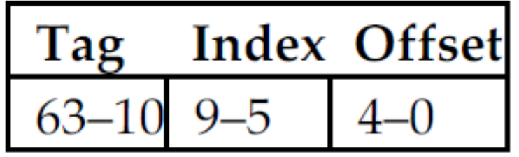

* 1. What is the cache block size (in words)?

4 words. Each block has 64 bits/ 8 bytes of data. For the offset inside one word, we need 3 bits. The other 2 bits can be used to find the index of blocks. Thus the cache block szie is 4 words.

* 1. How many blocks does the cache have?

32 blocks. Because we have 5 bits for indexing.

* 1. What is the ratio between total bits required for such a cache implementation over the data storage bits?

*Beginning from power on, the following byte-addressed cache references are recorded.*

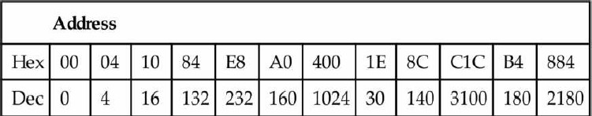 The total bits need for the cache is:

32 blocks * 4 word per row * 8 bytes per word = 1024 bytes = 8192 bits

To store data, each line will additionally need 54 bits for tag and 1 bit for valid bit.

So the total bits for data storage is 8192 + (54 + 1) * 32 = 9952 bits

The ratio is 9952 / 8192 = 1.215

* 1. For each reference, list (1) its tag, index, and offset, (2) whether it is a hit or a miss, and (3) which bytes were replaced (if any).

Index = 5 bits

Offset = 5 bits

|  |  |  |  |  |  |  |
| --- | --- | --- | --- | --- | --- | --- |
| Hex Address | Binary address | Tag (first 2 bits) | Index | Offset | Hit/ Miss | Bytes replaced |
| 0x00 | 0000 0000 0000 | 0x0 | 0x00 | 0x00 | Miss |  |
| 0x04 | 0000 0000 0100 | 0x0 | 0x00 | 0x04 | Hit |  |
| 0x10 | 0000 0001 0000 | 0x0 | 0x00 | 0x10 | Hit |  |
| 0x84 | 0000 1000 0100 | 0x0 | 0x04 | 0x04 | Miss |  |
| 0xe8 | 0000 1110 1000 | 0x0 | 0x07 | 0x08 | Miss |  |
| 0xa0 | 0000 1010 0000 | 0x0 | 0x05 | 0x00 | Miss |  |
| 0x400 | 0100 0000 0000 | 0x1 | 0x00 | 0x00 | Miss | 0x00-0x1f |
| 0x1e | 0000 0001 1110 | 0x0 | 0x00 | 0x1e | Miss | 0x400-0x41f |
| 0x8c | 0000 1000 1100 | 0x0 | 0x04 | 0x0c | Hit |  |
| 0xc1c | 1100 0001 1100 | 0x3 | 0x00 | 0x1c | Miss | 0x00-0x1f |
| 0xb4 | 0000 1011 0100 | 0x0 | 0x05 | 0x14 | Hit |  |
| 0x884 | 1000 1000 0100 | 0x2 | 0x04 | 0x04 | Miss | 0x80-0x9f |

* 1. What is the hit ratio?

4/12 = 0.333

* 1. List the final state of the cache, with each valid entry represented as a record of <*index, tag, data*>. For example,

# <0, 3, Mem[0xC00]-Mem[0xC1F]>

The final state of this cache is:

<0, 3, Mem[0xc00] - Mem[0xc1f]>

<4, 2, Mem[0x880] - Mem[0x89f]>

<5, 0, Mem[0x0a0] - Mem[0x0bf]>

<7, 0, Mem[0x0e0] - Mem[0x0ff]>

1. Recall that we have two write policies and two write allocation policies, and their combinations can be implemented either in L1 or L2 cache. Assume the following choices for L1 and L2 caches:

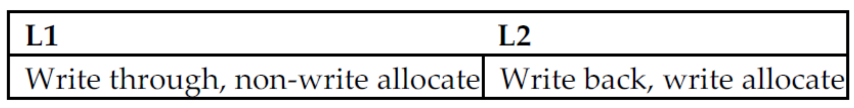

* 1. Buffers are employed between different levels of memory hierarchy to reduce access latency. For this given configuration, list the possible buffers needed between L1 and L2 caches, as well as L2 cache and memory.

L2 cache has higher write miss penalty than L1 cache. Thus the write buffer between L1 and L2 will help imporve the write miss latency of L2. The L2 cache will be benefited by the write buffers when the dirty block is replaced. That is because the new block will be read in before the dirty block is physically written to memory.

* 1. Describe the procedure of handling an L1 write-miss, considering the components involved and the possibility of replacing a dirty block.

When there is a write-miss in L1, the word needed is written directly to L2 because we are using the buffer right now. If this action causes a miss in L2, a block must be written to the L2 cache.

* 1. For a multilevel exclusive cache configuration (a block can only reside in one of the L1 and L2 caches), describe the procedures of handling an L1 write-miss and an L1 read- miss, considering the components involved and the possibility of replacing a dirty block.

After an L1 cache write miss, the block will residen in L2 rather than L1. Then there will be a read miss on the same block whcih requires the block in L2 to be written back to memory, transferred to L1.

1. Consider the following program and cache behaviors.



* 1. Suppose a CPU with a write-through, write-allocate cache achieves a CPI of 2. What are the read and write bandwidths (measured by bytes per cycle) between RAM and the cache? (Assume each miss generates a request for one block.)

Because CPI is 2, it means on average there is 0.5 instrcutions per cycle.

Read traffic:

25% of the instructions are data reading and 2% of them are data cache miss. Thus, a data read missing will generate:

0.5 * 25% * 2% * 64 = 0.16 bytes per cycle

10% of the instructions are data writing and 2% of them are data cache miss. Since the cache use write-allocate policy, when there is a write miss it also requires to read data from RAM. This part of reading traffic is:

0.5 * 10% * 2% * 64 = 0.064 bytes per cycle

0.3% of instructions will cause cache miss. This part of read traffic is:

0.5 * 0.3% * 64 = 0.096 bytes per cycle

Write traffic:

Because this cache use write-through policy, there is only 1 word (8 bytes) written back to the memory. This part of write traffic is:

0.5 * 10% * 8 = 0.4 bytes per cycle

In conclusion:

There are totally 0.16 + 0.064 + 0.096 = 0.32 bytes per cycle of read bandwidths and 0.4 bytes per cycle of write bandwidths.

* 1. For a write-back, write-allocate cache, assuming 30% of replaced data cache blocks are dirty, what are the read and write bandwidths needed for a CPI of 2?

The data read bandwidth is the same as 5.1 which is 0.32 bytes per cycle.

For data write bandwidth, it is different because now the cache use write-back policy.

When there is a cache miss (both read and write), the data is written to the memory.

Thus the write bandwidth is :

0.5 * (25% + 10%) * 2% * 0.3% * 64 = 6.72 * 10^(-5) bytes per cycle

1. Media applications that play audio or video files are part of a class of workloads called “streaming” workloads (i.e., they bring in large amounts of data but do not reuse much of it). Consider a video streaming workload that accesses a 512 KiB working set sequentially with the following word address stream:

# 0, 1, 2, 3, 4, 5, 6, 7, 8, 9 …

* 1. Assume a 64 KiB direct-mapped cache with a 32-byte block. What is the miss rate for the address stream above? How is this miss rate sensitive to the size of the cache or the working set? How would you categorize the misses this workload is experiencing, based on the 3C model?

The block size is 32 bytes so it contains 4 words. Thus on average the miss rate is 1/4.

The misses here is not possible to be avoided. It is not sensitive to the size of the cache or the size of the working set. It is sensitive to the block size and how the cache is accessed.

* 1. Re-compute the miss rate when the cache block size is 16 bytes, 64 bytes, and 128 bytes. What kind of locality is this workload exploiting?

For 16-bytes, the miss rate is: 1/2.

For 64-bytes, the miss rate is: 1/8.

For 128-bytes, the miss rate is: 1/16.

* 1. “*Prefetching*” is a technique that leverages predictable address patterns to speculatively bring in additional cache blocks when a particular cache block is accessed. One example of prefetching is a stream buffer that prefetches sequentially adjacent cache blocks into a separate buffer when a particular cache block is brought in. If the data are found in the prefetch buffer, it is considered as a hit, moved into the cache, and the next cache block is prefetched. Assume a two-entry stream buffer; and, assume that the cache latency is such that a cache block can be loaded before the computation on the previous cache block is completed. What is the miss rate for the address stream above?

Here the missrate is 0. Because the pre-fetch buffer will always prepare for the next requested data.

1. Cache block size (B) can affect both miss rate and miss latency. Assuming a machine with a base CPI of 1, and an average of 1.35 references (both instruction and data) per instruction, find the block size that minimizes the total miss latency given the following miss rates for various block sizes.

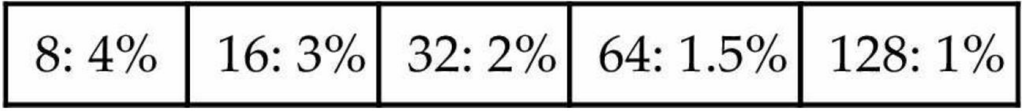

* 1. What is the optimal block size for a miss latency of 20 ×B cycles?

We can compare the AMAT for different caches to select the optimal block size.

AMAT for 8 blocks: 4% * 20 * 8 = 6.4

AMAT for 16 blocks: 3% * 20 * 16 = 9.6

AMAT for 32 blocks: 2% * 20 * 32 = 12.8

AMAT for 64 blocks: 1.5% * 20 * 64 = 19.2

AMAT for 128 blocks: 1% * 20 * 128 = 25.6

Thus, the optimal block size is 8.

* 1. What is the optimal block size for a miss latency of 24 +B cycles?

Similarly, we can have:

AMAT for 8 blocks: 4% * (24 + 8)= 1.28

AMAT for 16 blocks: 3% * (24 + 16)= 1.20

AMAT for 32 blocks: 2% * (24 + 32)= 1.12

AMAT for 64 blocks: 1.5% * (24 + 64)= 1.32

AMAT for 128 blocks: 1% * (24 + 128)= 1.52

Thus, the optimal block size is 32.

* 1. For constant miss latency, what is the optimal block size?

If the miss latency is constant, then the AMAT only depends the miss rate. Thus, the optimal block size is 128.

1. In this exercise, we will look at the different ways capacity affects overall performance. In general, cache access time is proportional to capacity. Assume that main memory accesses take 70 ns and that 36% of all instructions access data memory. The following table shows data for L1 caches attached to each of two processors, P1 and P2.

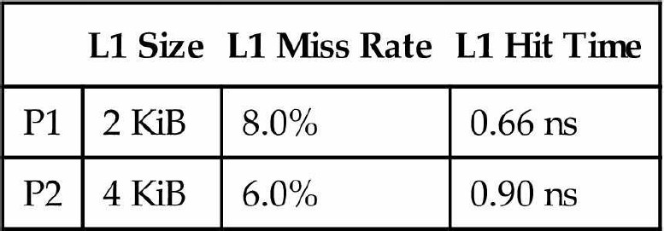

* 1. Assuming that the L1 hit time determines the cycle times for P1 and P2, what are their respective clock rates?

P1: 1 / (0.66 * 10^ -9) = 1.515 GHz

P2: 1 / (0.90 * 10^ -9) = 1.111 GHz

* 1. What is the Average Memory Access Time for P1 and P2 (in cycles)?

P1: 1 + 8% * (70 / 0.66) = 9.56 cycles

P2: 1 + 6% * (70 / 0.9) = 5.68 cycles

* 1. Assuming a base CPI of 1.0 without any memory stalls, what is the total CPI for P1 and P2? Which processor is faster? (When we say a “base CPI of 1.0”, we mean that instructions complete in one cycle, unless either the instruction access or the data access causes a cache miss.)

P1: 1 + (8% + 8% * 36% ) * (70 / 0.66) = 12.64 CPI

12.64 * 0.66 = 8.34 ns/ instruction

P2: 1 + (6% + 6% * 36% ) * (70 / 0.90) = 7.36 CPI

7.36 * 0.90 = 6.63 ns/ instruction

Thus, P2 is faster.

*we will now consider the addition of an L2 cache to P1 (to presumably make up for its limited L1 cache capacity). Use the L1 cache capacities and hit times from the previous table when solving these problems. The L2 miss rate indicated is its local miss rate.*

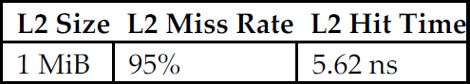

* 1. What is the AMAT for P1 with the addition of an L2 cache? Is the AMAT better or worse with the L2 cache?

AMAT of P1 with L2 cache:

1 + 8% * ((5.62 / 0.66) + 95% * (70 / 0.66)) = 9.85 cycles

Thus AMAT of P1 with L2 cache is slightly slower than without L2 cache.

* 1. Assuming a base CPI of 1.0 without any memory stalls, what is the total CPI for P1 with the addition of an L2 cache?

Total CPI = 9.85 + 36% * (9.85 - 1) = 13.04 cycles

* 1. What would the L2 miss rate need to be in order for P1 with an L2 cache to be faster than P1 without an L2 cache?

We want to reach that:

AMAT with L2 < AMAT with only L1

1 + 8% * ((5.62 / 0.66) + miss rate * (70 / 0.66)) < 9.56 cycles

miss rate < 91.59%

* 1. What would the L2 miss rate need to be in order for P1 with an L2 cache to be faster than P2 without an L2 cache?

For this question we want is

CPI of P1 * 0.66ns < 6.63ns

(AMAT of P1 + 36% * (AMAT of P1 - 1)) * 0.66ns < 6.63ns

AMAT of P1 < 7.65

1 + 8% * ((5.62 / 0.66) + miss rate * (70 / 0.66)) < 7.65

miss rate < 69.28%

1. This exercise examines the effect of different cache designs, specifically comparing associative caches to the direct-mapped caches from *Section 5.4*. For these exercises, refer to the sequence of word address shown below.

# 0x03, 0xb4, 0x2b, 0x02, 0xbe, 0x58, 0xbf, 0x0e, 0x1f, 0xb5, 0xbf, 0xba, 0x2e, 0xce

* 1. Sketch the organization of a three-way set associative cache with two-word blocks and a total size of 48 words. Your sketch should have a style similar to *Figure 5.18*, but clearly show the width of the tag and data fields.

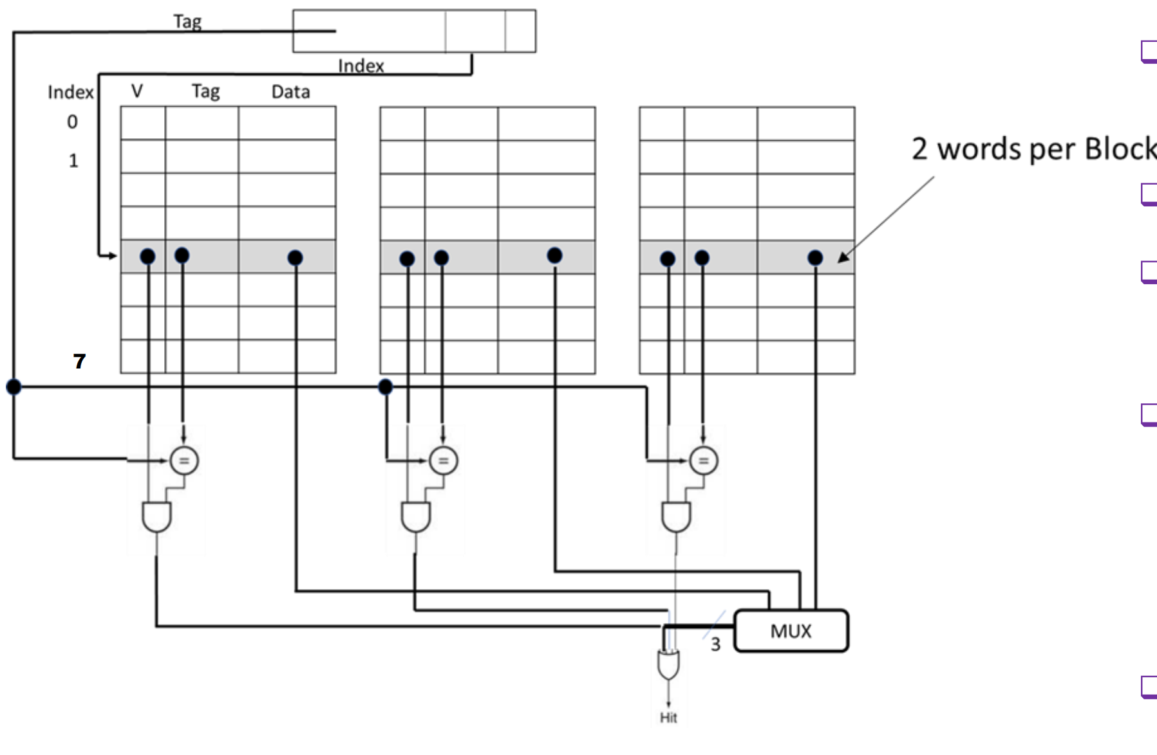

* 1. Trace the behavior of the cache from Exercise 9.1 Assume a true LRU replacement policy. For each reference, identify
     + *the binary word address,*
     + *the tag,*
     + *the index,*
     + *the offset*
     + *whether the reference is a hit or a miss, and*
     + *which tags are in each way of the cache after the reference has been handled.*

|  |  |  |  |  |  |  |  |  |
| --- | --- | --- | --- | --- | --- | --- | --- | --- |
| Hex word address | Binary address | Tag | Index | Offset | Hit/ Miss | Way 0 | Way 1 | Way 2 |
| 0x03 | 0000 0011 | 0x0 | 1 | 1 | Miss | Tag(1)=0 |  |  |
| 0xb4 | 1011 0100 | 0xb | 2 | 0 | Miss | Tag(1)=0  Tag(2)=b |  |  |
| 0x2b | 0010 1011 | 0x2 | 5 | 1 | Miss | Tag(1)=0  Tag(2)=b  Tag(5)=2 |  |  |
| 0x02 | 0000 0010 | 0x0 | 1 | 0 | Hit | Tag(1)=0  Tag(2)=b  Tag(5)=2 |  |  |
| 0xbe | 1011 1110 | 0xb | 7 | 0 | Miss | Tag(1)=0  Tag(2)=b  Tag(5)=2  Tag(7)=b |  |  |
| 0x58 | 0101 1000 | 0x5 | 4 | 0 | Miss | Tag(1)=0  Tag(2)=b  Tag(5)=2  Tag(7)=b  Tag(4)=5 |  |  |
| 0xbf | 1011 1111 | 0xb | 7 | 1 | Hit | Tag(1)=0  Tag(2)=b  Tag(5)=2  Tag(7)=b  Tag(4)=5 |  |  |
| 0x0e | 0000 1110 | 0x0 | 7 | 0 | Miss | Tag(1)=0  Tag(2)=b  Tag(5)=2  Tag(7)=b  Tag(4)=5 | Tag(7)=0 |  |
| 0x1f | 0001 1111 | 0x1 | 7 | 1 | Miss | Tag(1)=0  Tag(2)=b  Tag(5)=2  Tag(7)=b  Tag(4)=5 | Tag(7)=0 | Tag(7)=1 |
| 0xb5 | 1011 0101 | 0xb | 2 | 1 | Hit | Tag(1)=0  Tag(2)=b  Tag(5)=2  Tag(7)=b  Tag(4)=5 | Tag(7)=0 | Tag(7)=1 |
| 0xbf | 1011 1111 | 0xb | 7 | 1 | Hit | Tag(1)=0  Tag(2)=b  Tag(5)=2  Tag(7)=b  Tag(4)=5 | Tag(7)=0 | Tag(7)=1 |
| 0xba | 1011 1010 | 0xb | 5 | 0 | Miss | Tag(1)=0  Tag(2)=b  Tag(5)=2  Tag(7)=b  Tag(4)=5 | Tag(7)=2  Tag(5)=b | Tag(7)=1 |
| 0x2e | 0010 1110 | 0x2 | 7 | 0 | Miss | Tag(1)=0  Tag(2)=b  Tag(5)=2  Tag(7)=b  Tag(4)=5 | Tag(7)=2  Tag(5)=b | Tag(7)=1 |
| 0xce | 1100 1110 | 0xc | 7 | 0 | Miss | Tag(1)=0  Tag(2)=b  Tag(5)=2  Tag(7)=b  Tag(4)=5 | Tag(7)=2  Tag(5)=b | Tag(7)=c |

* 1. Sketch the organization of a fully associative cache with one-word blocks and a total size of eight words. Your sketch should have a style similar to Figure 5.18, but clearly show the width of the tag and data fields.

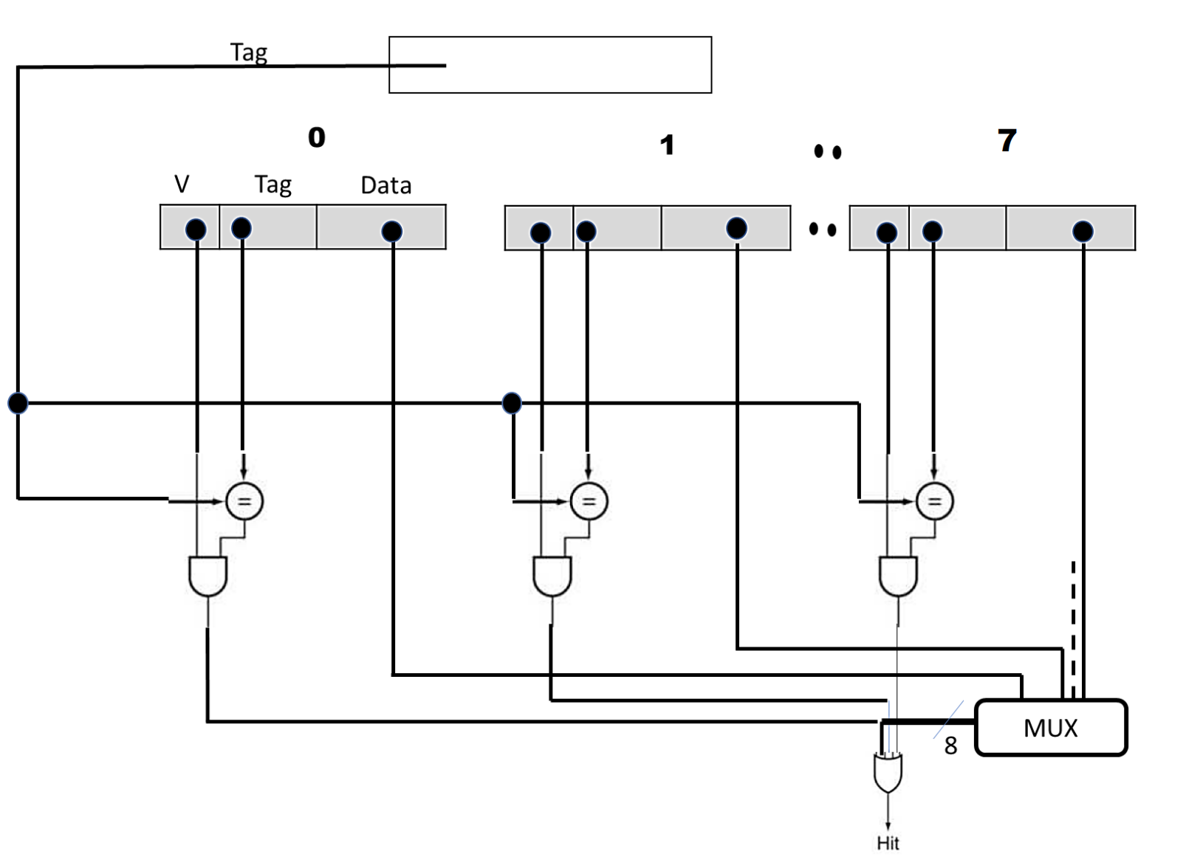

* 1. Trace the behavior of the cache from Exercise 9.3. Assume a true LRU replacement policy. For each reference, identify
     + *the binary word address,*
     + *the tag,*
     + *the index,*
     + *the offset,*
     + *whether the reference is a hit or a miss*
     + *the contents of the cache after each reference has been handled.*

|  |  |  |  |  |
| --- | --- | --- | --- | --- |
| Hex word address | Binary address | Tag | Hit/ Miss | Contents |
| 0x03 | 0000 0011 | 0x03 | Miss | 3 |
| 0xb4 | 1011 0100 | 0xb4 | Miss | 3,b4 |
| 0x2b | 0010 1011 | 0x2b | Miss | 3,b4,2b |
| 0x02 | 0000 0010 | 0x02 | Miss | 3,b4,2b,2 |
| 0xbe | 1011 1110 | 0xbe | Miss | 3,b4,2b,2,be |
| 0x58 | 0101 1000 | 0x58 | Miss | 3,b4,2b,2,be,58 |
| 0xbf | 1011 1111 | 0xbf | Miss | 3,b4,2b,2,be,58,bf |
| 0x0e | 0000 1110 | 0x0e | Miss | 3,b4,2b,2,be,58,bf,e |
| 0x1f | 0001 1111 | 0x1f | Miss | b4,2b,2,be,58,bf,e,1f |
| 0xb5 | 1011 0101 | 0xb5 | Miss | 2b,2,be,58,bf,e,1f,b5 |
| 0xbf | 1011 1111 | 0xbf | Hit | 2b,2,be,58,e,1f,b5,bf |
| 0xba | 1011 1010 | 0xba | Miss | 2,be,58,e,1f,b5,bf,ba |
| 0x2e | 0010 1110 | 0x2e | Miss | be,58,e,1f,b5,bf,ba,2e |
| 0xce | 1100 1110 | 0xce | Miss | 58,e,1f,b5,bf,ba,2e,ce |

* 1. Sketch the organization of a fully associative cache with two-word blocks and a total size of eight words. Your sketch should have a style similar to Figure 5.18, but clearly show the width of the tag and data fields.

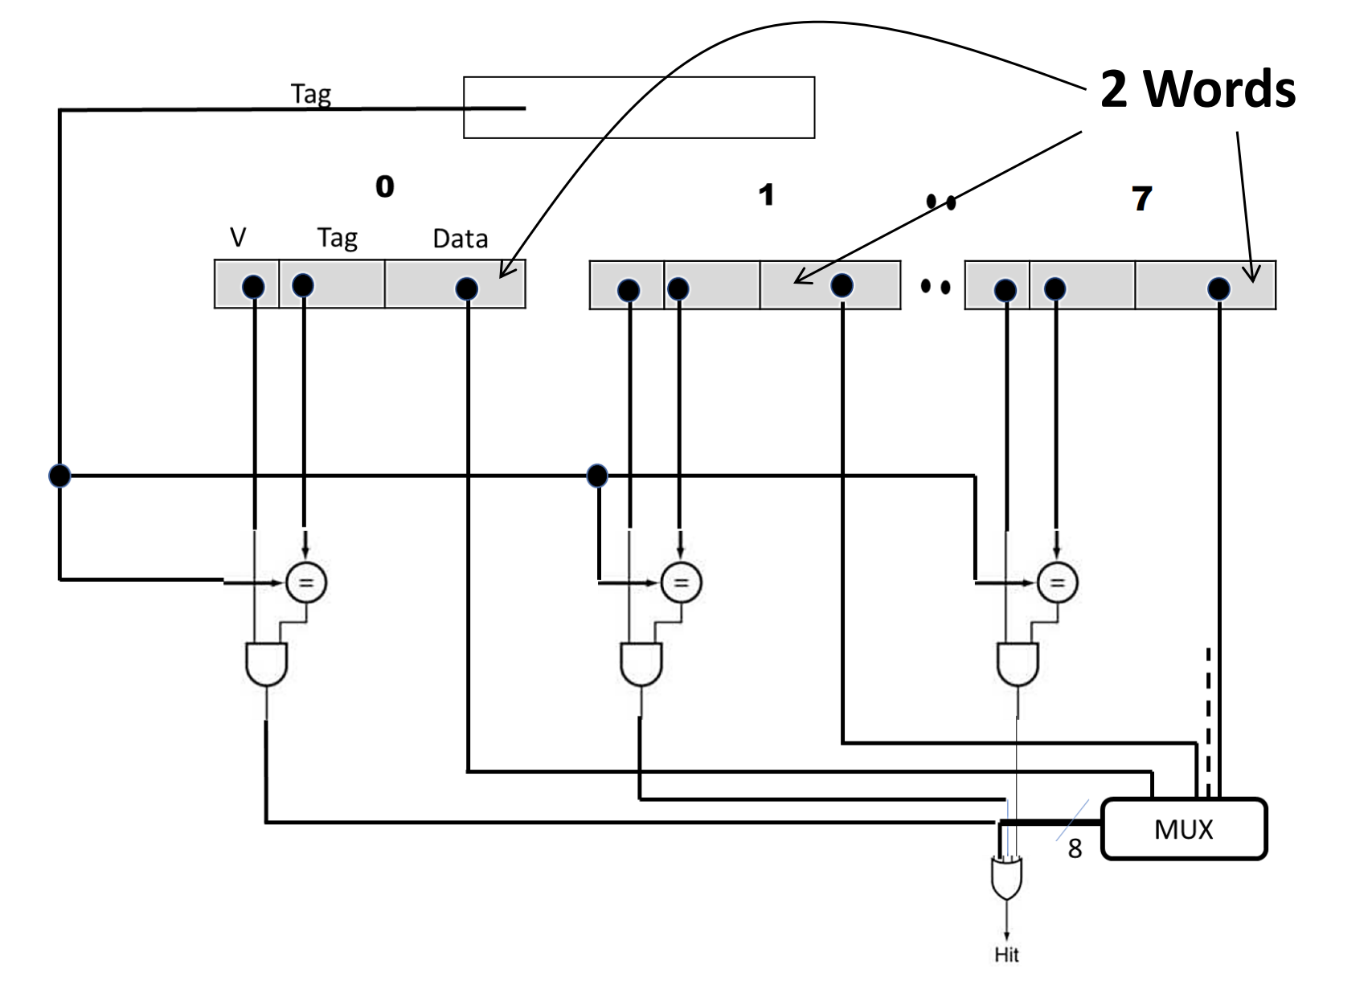

* 1. Trace the behavior of the cache from Exercise 9.5. Assume an LRU replacement policy. For each reference, identify
     + *the binary word address,*
     + *the tag,*
     + *the index,*
     + *the offset,*
     + *whether the reference is a hit or a miss,*
     + *the contents of the cache after each reference has been handled.*

|  |  |  |  |  |  |
| --- | --- | --- | --- | --- | --- |
| Hex word address | Binary address | Tag | Offset | Hit/ Miss | Contents |
| 0x03 | 0000 0011 | 0x01 | 1 | Miss | [2,3] |
| 0xb4 | 1011 0100 | 0x5a | 0 | Miss | [2,3],[b4,b5] |
| 0x2b | 0010 1011 | 0x15 | 1 | Miss | [2,3],[b4,b5],[2a,2b] |
| 0x02 | 0000 0010 | 0x01 | 0 | Hit | [b4,b5],[2a,2b],[2,3] |
| 0xbe | 1011 1110 | 0x5f | 0 | Miss | [b4,b5],[2a,2b],[2,3],[be,bf] |
| 0x58 | 0101 1000 | 0x2c | 0 | Miss | [2a,2b],[2,3],[be,bf],[58,59] |
| 0xbf | 1011 1111 | 0x5f | 1 | Hit | [2a,2b],[2,3],[58,59],[be,bf] |
| 0x0e | 0000 1110 | 0x07 | 0 | Miss | [2,3],[58,59],[be,bf],[e,f] |
| 0x1f | 0001 1111 | 0x0f | 1 | Miss | [58,59],[be,bf],[e,f],[1e,1f] |
| 0xb5 | 1011 0101 | 0x5a | 1 | Miss | [be,bf],[e,f],[1e,1f],[b4,b5] |
| 0xbf | 1011 1111 | 0x5f | 1 | Hit | [e,f],[1e,1f],[b4,b5],[be,bf] |
| 0xba | 1011 1010 | 0x5d | 0 | Miss | [1e,1f],[b4,b5],[be,bf],[ba,bb] |
| 0x2e | 0010 1110 | 0x17 | 0 | Miss | [b4,b5],[be,bf],[ba,bb],[2e,2f] |
| 0xce | 1100 1110 | 0x67 | 0 | Miss | [be,bf],[ba,bb],[2e,2f],[ce,cf] |

* 1. Repeat Exercise 9.6 using MRU (most recently used) replacement.

|  |  |  |  |  |  |
| --- | --- | --- | --- | --- | --- |
| Hex word address | Binary address | Tag | Offset | Hit/ Miss | Contents |
| 0x03 | 0000 0011 | 0x01 | 1 | Miss | [2,3] |
| 0xb4 | 1011 0100 | 0x5a | 0 | Miss | [2,3],[b4,b5] |
| 0x2b | 0010 1011 | 0x15 | 1 | Miss | [2,3],[b4,b5],[2a,2b] |
| 0x02 | 0000 0010 | 0x01 | 0 | Hit | [b4,b5],[2a,2b],[2,3] |
| 0xbe | 1011 1110 | 0x5f | 0 | Miss | [b4,b5],[2a,2b],[2,3],[be,bf] |
| 0x58 | 0101 1000 | 0x2c | 0 | Miss | [b4,b5],[2a,2b],[2,3],[58,59] |
| 0xbf | 1011 1111 | 0x5f | 1 | Hit | [b4,b5],[2a,2b],[2,3],[be,bf] |
| 0x0e | 0000 1110 | 0x07 | 0 | Miss | [b4,b5],[2a,2b],[2,3],[e,f] |
| 0x1f | 0001 1111 | 0x0f | 1 | Miss | [b4,b5],[2a,2b],[2,3],[1e,1f] |
| 0xb5 | 1011 0101 | 0x5a | 1 | Miss | [2a,2b],[2,3],[1e,1f],[b4,b5] |
| 0xbf | 1011 1111 | 0x5f | 1 | Hit | [2a,2b],[2,3],[1e,1f],[be,bf] |
| 0xba | 1011 1010 | 0x5d | 0 | Miss | [2a,2b],[2,3],[1e,1f],[ba,bb] |
| 0x2e | 0010 1110 | 0x17 | 0 | Miss | [2a,2b],[2,3],[1e,1f],[2e,2f] |
| 0xce | 1100 1110 | 0x67 | 0 | Miss | [2a,2b],[2,3],[1e,1f],[ce,cf] |

* 1. Repeat Exercise 9.6 using the optimal replacement policy (i.e., the one that gives the lowest miss rate).

|  |  |  |  |  |  |
| --- | --- | --- | --- | --- | --- |
| Hex word address | Binary address | Tag | Offset | Hit/ Miss | Contents |
| 0x03 | 0000 0011 | 0x01 | 1 | Miss | [2,3] |
| 0xb4 | 1011 0100 | 0x5a | 0 | Miss | [2,3],[b4,b5] |
| 0x2b | 0010 1011 | 0x15 | 1 | Miss | [2,3],[b4,b5],[2a,2b] |
| 0x02 | 0000 0010 | 0x01 | 0 | Hit | [2,3],[b4,b5],[2a,2b] |
| 0xbe | 1011 1110 | 0x5f | 0 | Miss | [2,3],[b4,b5],[2a,2b],[be,bf] |
| 0x58 | 0101 1000 | 0x2c | 0 | Miss | [58,59],[b4,b5],[2a,2b],[be,bf] |
| 0xbf | 1011 1111 | 0x5f | 1 | Hit | [58,59],[b4,b5],[2a,2b],[be,bf] |
| 0x0e | 0000 1110 | 0x07 | 0 | Miss | [e,f],[b4,b5],[2a,2b],[be,bf] |
| 0x1f | 0001 1111 | 0x0f | 1 | Miss | [1e,1f],[b4,b5],[2a,2b],[be,bf] |
| 0xb5 | 1011 0101 | 0x5a | 1 | Miss | [1e,1f],[b4,b5],[2a,2b],[be,bf] |
| 0xbf | 1011 1111 | 0x5f | 1 | Hit | [1e,1f],[b4,b5],[2a,2b],[be,bf] |
| 0xba | 1011 1010 | 0x5d | 0 | Miss | [1e,1f],[b4,b5],[ba,bb],[be,bf] |
| 0x2e | 0010 1110 | 0x17 | 0 | Miss | [1e,1f],[b4,b5],[2e,2f],[be,bf] |
| 0xce | 1100 1110 | 0x67 | 0 | Miss | [1e,1f],[b4,b5],[ce,cf],[be,bf] |

1. Multilevel caching is an important technique to overcome the limited amount of space that a first-level cache can provide while still maintaining its speed. Consider a processor with the following parameters:

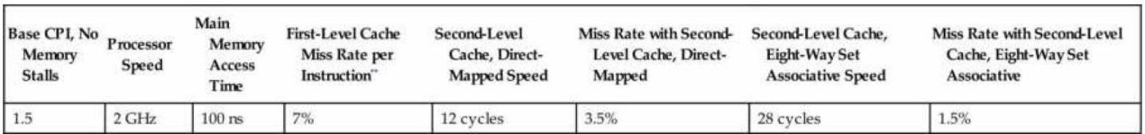

*\*\*First Level Cache miss rate is per instruction. Assume the total number of L1 cache misses*

*(instruction and data combined) is equal to 7% of the number of instructions.*

* 1. Calculate the CPI for the processor in the table using: 1) only a first-level cache, 2) a second-level direct mapped cache, and 3) a second-level eight-way set associative cache. How do these numbers change if main memory access time doubles? (Give each change as both an absolute CPI and a percent change.) Notice the extent to which an L2 cache can hide the effects of a slow memory.

The original main memory access time is 100 ns.

Since the processor speed is 2 GHz, the cycle time is 1 / 2GHz = 0.5 ns

Thus a main memory access requires 100 / 0.5 = 200 cycles.

The CPI with original main memory access time:

L1 only: 1.5 + 7% * 200 = 15.5

A L2 direct mapped cache: 1.5 + 7% * (12 + 3.5% * 200) = 2.83

L2 8-way associative cache: 1.5 + 7% * (28 + 1.5% * 200) = 3.67

If the main memory access time is doubled:

L1 only: 1.5 + 7% * 400 = 29.5, it is increased by (29.5 / 15.5) - 1 = 90.32%

A L2 direct mapped cache: 1.5 + 7% * (12 + 3.5% * 200) = 3.32 , it is increased by (3.32 / 2.83) - 1 = 17.31%

L2 8-way associative cache: 1.5 + 7% * (28 + 1.5% * 200) = 3.88, it is increased by (3.88 / 3.67) - 1 = 5.72%

* 1. It is possible to have an even greater cache hierarchy than two levels? Given the processor above with a second-level, direct-mapped cache, a designer wants to add a third-level cache that takes 50 cycles to access and will have a 13% miss rate. Would this provide better performance? In general, what are the advantages and disadvantages of adding a third-level cache?

With a L3 cache, the CPI is:

1.5 + 7% * (12 + 3.5% * (50 + 13% * 100)) = 2.49435

So it does reduce the CPI.

The main advantage is reducing the overall memory access time.

The disadvantage is adding a L3 cache will need more physical spaces.

* 1. In older processors, such as the Intel Pentium or Alpha 21264, the second level of cache was external (located on a different chip) from the main processor and the first- level cache. While this allowed for large second-level caches, the latency to access the cache was much higher, and the bandwidth was typically lower because the second-level cache ran at a lower frequency. Assume a 512 KiB off-chip second level cache has a miss rate of 4%. If each additional 512 KiB of cache lowered miss rates by 0.7%, and the cache had a total access time of 50 cycles, how big would the cache have to be to match the performance of the second-level direct-mapped cache listed above?

It is impossible to match the performance of the second level direct mapped cache.

The reason is if we want to match the performance, assuming the k is miss rate, the CPI needs to be:

1.5 + 7% * (50 + k * 200) < 2.83

Solving this inequality we can have:

k < -0.155

which means we need a negative miss rate. Thus it’s impossible to match the performance.